**CS401 Assignment #2 Spring 2022**

***Name: Abdul Rehman.***

***VU-ID: BC200403287.***

**Question:**

**Group#02: All Graduate Programs and all other than the master of programs students**

Write a program in assembly language that divides the screen into three equal vertical colors as the National Flag of Italy using BIOS services. Moreover, any character/text written on the white color area of the flags should blink, on the rest of the area of the flag the text color should not be blinking as shown in picture#02 for more detail view the animated GIF file attached with the assignment.



**(Picture#02).** **Output of National Flag of Italy for All Graduate Programs and all other than the master of programs students.**

**Solution:**

**Assembly Code of file “arehman1.asm”:**

[org 0x0100]

jmp start

start:

MOV AX,0600h

MOV BH,20h

MOV DL,01h

MOV CX,0000h

MOV DX,181ah

INT 10h

MOV AX,0600h

MOV BH,70h

MOV DL,01h

MOV CX,001bh

MOV DX,1834h

INT 10h

MOV AX,0600h

MOV BH,47h

MOV CX,0034h

MOV DX,184fh

INT 10h

MOV AH,02h

MOV BH,00h

MOV DX,0x101b

INT 10h

MOV AH,6

MOV AL,0

MOV CL,1bh

MOV CH,0ch

MOV DL,33h

MOV DH,18h

MOV BH,01110000b

OR BH,10000000b

INT 10h

MOV AX,4c00h

INT 21h

**Screenshots:**

* **DOSBox:**

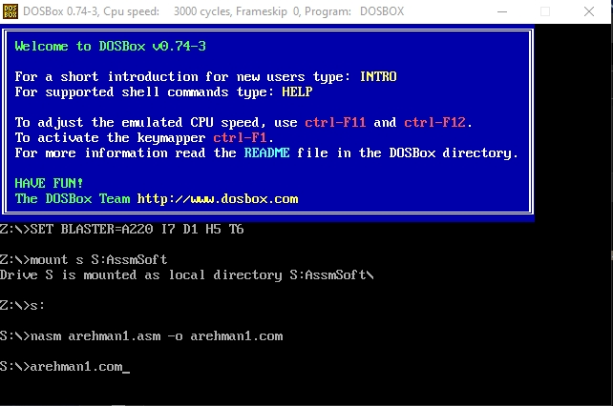

* **Final Output:**

The mid “white” area of the Italy flag is blinking.

